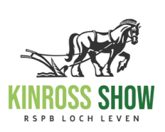
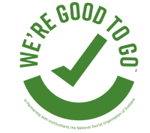
A Short Guide to Covid Provisions for Our Members at Kinross Show 2021

Introduction: This guide has been drawn up to clearly inform you of what to expect on the day and how we are working hard to provide a safe show day for us all. Some people will be apprehensive about attending an open air event for the first time in several years. Please bear this in mind.
In the interest of our mutual well-being, we ask that all people attending Kinross Show, read and adhere to the guidance below.
What we have put in place: Things will be different- do not expect your normal show.
- Layout - The layout will be spaced and more open in all aspects, we will utilise the uphill land for generously spaced socialising.
- A quieter zone will be available for protected socialising at the heart of the show.
- There will be only a few marquees- so prepare yourself for all weathers.
- A Single entrance and exit with off road queuing.
- A wide one way flow to avoid bottlenecks.
- Multiple hand sanitiser points throughout the grounds.
- Cleaning of frequent touch points.
- Prepaid tickets and catering/retail purchases by contactless card payment.
- The working/ volunteer team will all have Lateral Flow Tests from setup, to minimise risk.
- Covid team- identifiable by blue bibs, will be on hand to help.

Before you come
- Your Online ticket- please print it out or take a photo. This will be easily available to speed entry.
- Bring a face covering/mask
- Please familiarise yourself with the SHOW MAP layout and attractions on kinross-show.co.uk. This will let you plan your day and what to expect going in and moving around.
- Only attend if you are well.

On the day
- NO ticket NO entry. You will be assigned barcoded complimentary tickets. Please purchase any additional tickets in advance, online.
- Security staff will be employed to scan in each ticket for Test and Protect. You may print out or have the ticket on your phone.
- Anyone attending without a ticket (or with a duplicate) will be turned away.

Temperature checks will be carried out prior to entering show. Anyone with a temperature >37.8 degrees will be asked to self isolate and their travelling companions will not be allowed in.
Please comply with Covid Mitigation throughout the day.
- Think as you approach people, adhere to 2m distancing where possible.
- Wear a mask if entering marquees or if 2m is not possible.
- Time your food and drink purchases to avoid long queues.
- Use hand sanitiser frequently.
But most of all- ENJOY YOUR DAY AND THE COMPANY OF THOSE YOU HAVE NOT SEEN IN A LONG TIME.

After the show- Should anyone develop symptoms or test positive for Covid 19 within 14 days, you agree to contact the Covid Team on 07771191686 so Test and Protect may be initiated.
Increased risk- if you are at increased risk of complications of covid please contact the team in confidence so we may arrange for additional measures to let you enjoy your day. Raise concerns if others are not following covid mitigation.
Contact Covid team on 07771191686.

